MSBA 210 (2024) Final Project Assignment

Aryan Vimalbhai Shah
Krish Vijaykumar Modi
Krutika Gordhanbhai Vekariya
Eberhardt School of Business, University of The Pacific
MSBA 210 Business Analytics
Chong Huang

TABLE OF CONTENT
NO. | CONTENT | PAGE NO
1 | Introduction | 3
2 | Background | 3
3 | Data Analysis and Pivot Table | 7
4 | Covariance analysis | 9
5 | Regression Analysis | 11
6 | Top 30 D color data | 13
7 | Dashboard | 14
8 | Conclusion | 14
9 | Appendix (Raw Data) | 15
10 | References | 18

Introduction:
This report takes you on an exploration into the sparkling world of diamonds, aiming to unravel the mysteries behind their pricing. We're focusing on how aspects like color, clarity, and carat weight shape the value of these precious stones. To keep things straightforward, we've held the cut quality constant at 'Ideal' for all diamonds examined.
Through this investigation, we hope to pinpoint exactly what factors play the most significant roles in determining a diamond’s worth in the market. Our analysis is designed to isolate and highlight the critical attributes that contribute to a diamond’s perceived value, providing insights that are both illuminating and actionable for enthusiasts and professionals alike.
Here are the questions that we have asked:
- How Diamonds Differ in Price: We explore the various factors that cause differences in diamond prices, focusing particularly on how the attributes of each diamond contribute to its market price.
- Color and Clarity Champions: We investigate which of these two characteristics—color or clarity—has a more significant impact on a diamond's value, helping to determine which attribute holds more weight in the pricing of diamonds.
- Our goal is to uncover what drives the price of diamonds, with a special focus on color and clarity. We're set to find out which of these attributes matters more in the market, aiming to provide a clearer understanding of how diamonds are valued.

Background:

Diamonds have captivated the human imagination for centuries, not only because of their stunning beauty and remarkable hardness but also due to their rarity, making them symbols of wealth and prestige throughout history. The process of mining diamonds has significantly reshaped economies and environments around the world and carries with it a rich and complex history.
- Extraction and Global Distribution: The story of diamond mining began in India, with other significant deposits later discovered in Brazil and South Africa in the 18th and 19th centuries. These discoveries transformed the landscape of diamond mining, shifting global trade patterns and influencing economic development across continents. The pursuit of these gemstones has brought about profound environmental impacts and social transformations.
- Ethical Issues in Diamond Trading: The darker side of diamond mining has given rise to the term 'blood diamonds,' which refers to stones mined in war zones and sold to finance conflicts against governments. The international community's concerns over these ethical issues led to the creation of the Kimberley Process, an initiative designed to stem the flow of conflict diamonds and ensure that diamond markets do not fund violence.
Role in Global Economy: Beyond their allure, diamonds play a crucial role in the economies of several countries, contributing significantly to national revenues and providing jobs for thousands of people. The diamond industry is also a major player in the global luxury goods market, setting trends and shaping consumer behavior worldwide.
This rich tapestry of history and economics sets the stage for our exploration into how diamonds are valued today, providing a context that links the past with the present in the dynamic world of diamond trading.
Factors Affecting Price Changing in Diamond:
When assessing the value of diamonds, four key factors—known affectionately as the "Four Cs"—come into play. Each of these characteristics has a significant influence on how much a diamond is worth:

- Carat: This is the measure of a diamond's weight, where one carat equals 0.2 grams. The weight of a diamond is a straightforward indicator that affects its price. Typically, the heavier the diamond, the more expensive it becomes, primarily because larger diamonds are rarer and more desirable.

- Color: Diamonds are graded on a spectrum that ranges from completely colorless to a light yellow or brown tint. The scale for this starts at D, representing colorless, and goes all the way to Z, which indicates a light color. The most prized diamonds are those that are pure and colorless, as they reflect light beautifully, making them exceptionally brilliant and, consequently, more valuable.

- Clarity: This characteristic is all about the appearance of the diamond under magnification. Clarity refers to how free the diamond is from inclusions (internal flaws) and blemishes (surface imperfections). The clearer a diamond, meaning the fewer the inclusions, the more valuable it is because it's rarer and sparkles more due to less interference with light.

- Cut: Perhaps the most crucial aspect in terms of aesthetics, the cut of a diamond determines its symmetry, proportions, and the ability to reflect light. An expertly cut diamond will dazzle brilliantly, catching light perfectly to showcase its fiery brilliance. The quality of the cut can dramatically enhance the diamond's visual appeal and thus its market price.

These four aspects deeply influence a diamond's charm and character, weaving together the story of its journey from a rough stone to a breathtaking gemstone. Understanding these factors helps illuminate why certain diamonds capture our hearts and wallets more than others.

Data Analysis and Pivot Table:
To gather insights into diamond pricing, we turned to some of the top online diamond retailers, such as Brilliant Earth, Blue Nile, With Clarity, and James Allen. These sites are renowned for their detailed and trustworthy information on diamonds, making them ideal sources for our study. Our approach to collecting data was careful and structured.
We chose to focus on diamonds that were uniformly rated as 'Ideal' in their cut to keep our analysis consistent. We specifically looked at diamonds ranging from 0.50 to 0.69 carats, capturing a variety of natural and synthetic diamonds. This allowed us to explore the nuances of price differences based on color and clarity under comparable conditions. Our method ensures a thorough and precise dataset, which is crucial for delivering reliable insights into the factors that influence diamond pricing.
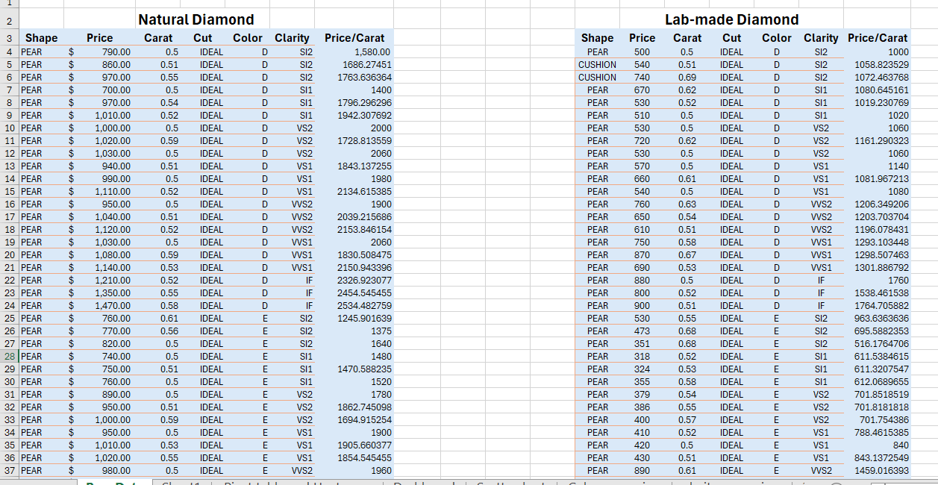
After gathering our data, we calculated the price per carat for each diamond to differentiate between the overall price and the price per unit, giving us deeper insight into the true cost.
With this detailed information, we then set up pivot tables for natural and lab-made diamonds. Pivot tables are incredibly helpful in breaking down and understanding data more effectively, allowing us to quickly identify trends and make sense of pricing patterns in the diamond market.
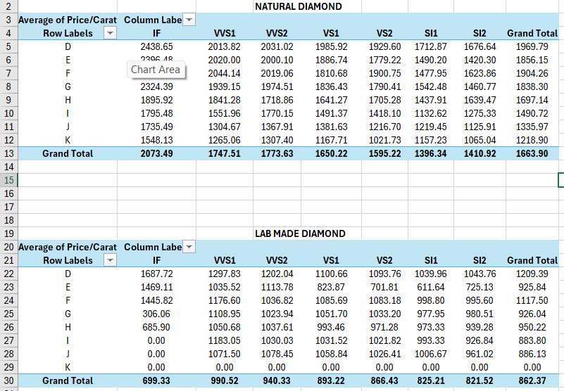
We also used heat maps to add a visual layer to our analysis, making it easier to see how lab-created diamonds stack up against natural ones, and how both compare to industry benchmarks like the Rapaport report. These colorful displays help us quickly spot trends and differences, bringing the data to life in a clear and engaging way.
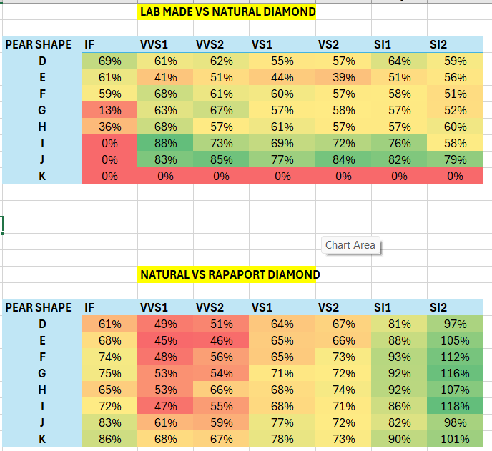
Synthetic versus Natural Diamonds: A Comparative Analysis:
The heat map for lab-grown diamonds reveals that these diamonds often sell for much less than natural ones, with discounts ranging from about 13% to over 88%. This lower pricing reflects the fact that creating diamonds in a lab is generally less costly than the traditional method of mining them from the earth.
Comparing Natural Diamonds with the Rapaport Price Index:
The heat map for natural diamonds indicates that they often fetch prices significantly above those listed on the Rapaport price list, with markups ranging from 45% to over 118%. The Rapaport list primarily reflects wholesale prices, which are lower because they don't include the retail markup that covers store overheads and profit margins. As a result, the price consumers pay at retail can be substantially higher, reflecting these additional costs.

Covariance analysis:
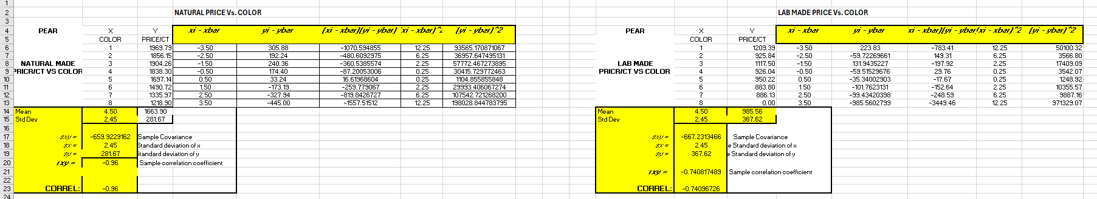

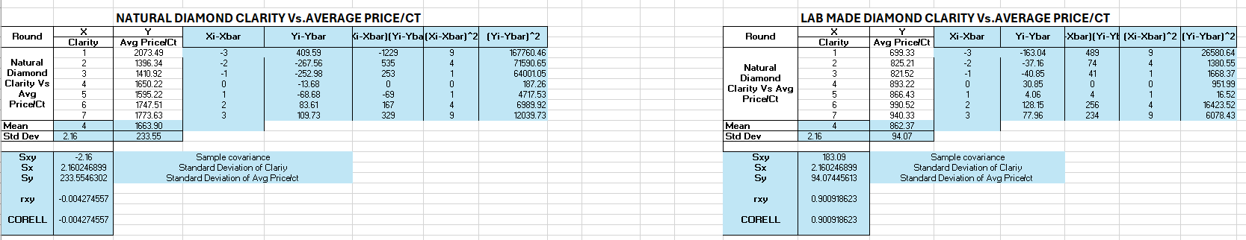
1. Color and Price per Carat in Natural Diamonds:
- Sample Covariance: -659.92
This striking figure reveals a strong inverse relationship between the color grades and the price per carat for natural diamonds. Essentially, as the color grade improves, the price per carat tends to drop.
2. Clarity and Average Price per Carat in Natural Diamonds:
- Sample Covariance: -2.16
This positive number suggests a moderate upward connection between the clarity of natural diamonds and their average pricing per carat. It seems that the clearer the diamond, the higher the price it commands.
3. Color and Price per Carat in Lab-Made Diamonds:
- Sample Covariance: -667.23
This indicates a negative relationship between color grades and price per carat for lab-made diamonds, though the effect is not as pronounced as in natural diamonds. Lower color grades correlate with lower prices.
4. Clarity and Average Price per Carat in Lab-Made Diamonds:
- Sample Covariance: 183.09
Interestingly, this negative covariance suggests a strong inverse trend between clarity grades and the average price per carat in lab-made diamonds. Higher clarity seems to lead to lower prices, contrasting with natural diamonds.

Regression Analysis:
Lab-Made Diamonds:
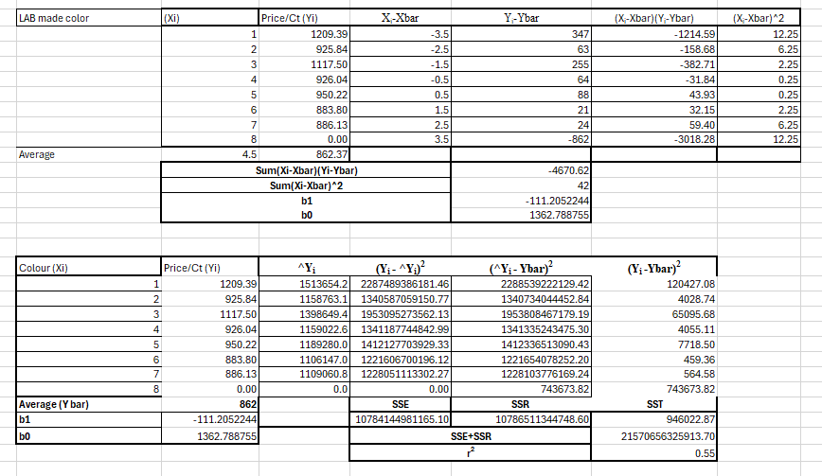
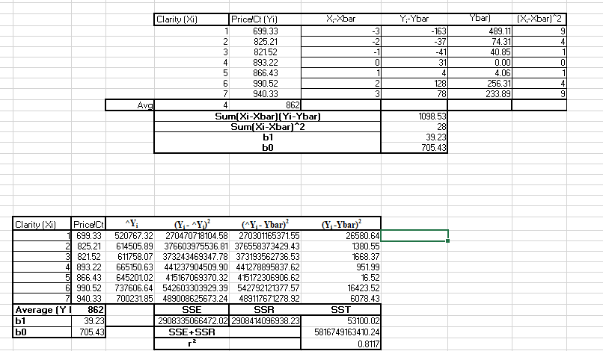
In lab-made diamonds, color and clarity continue to influence prices, though not as strongly as in natural diamonds. Color has a moderate effect on price variations, suggesting it's an important factor, but not the primary driver. On the other hand, clarity has a more substantial impact, indicating that it is a key determinant of value in the lab-made diamond market.
Natural Diamonds:
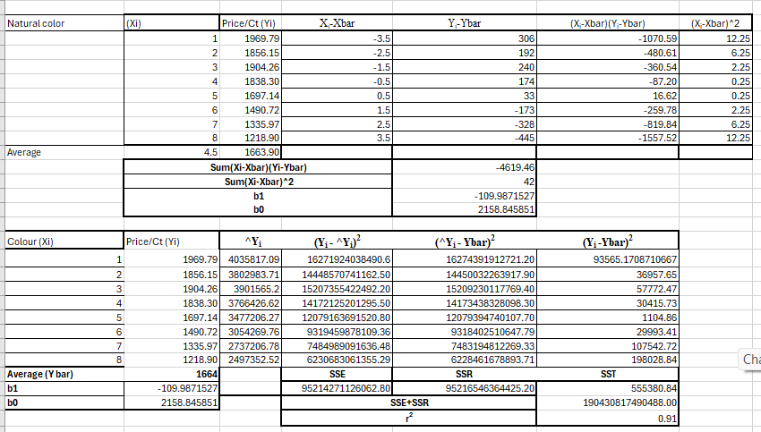
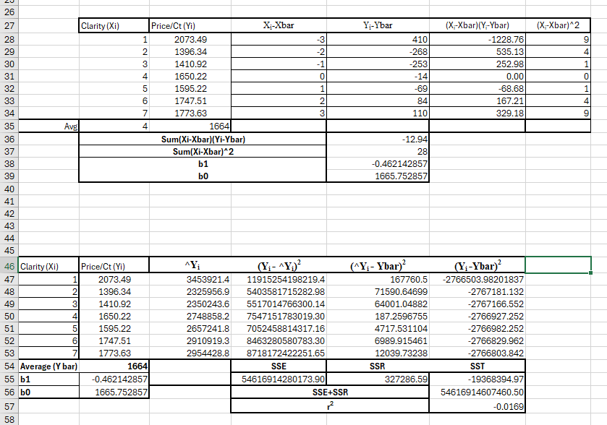
In the realm of natural diamonds, both color and clarity are pivotal in determining their prices. Diamonds with a higher color grade, such as D, generally command higher prices due to their rarity and appeal. The link between color and pricing is strong, with color being a major driver behind the price variations.
Similarly, clarity is crucial; diamonds that are closer to flawless have fewer imperfections and tend to fetch higher prices. Clarity significantly influences the price, making it a key factor in the valuation of natural diamonds.
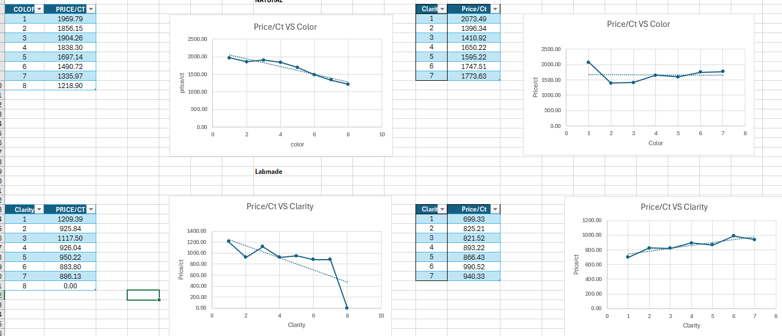
For both natural and lab-made diamonds, color and clarity play significant roles in setting their prices. However, natural diamonds tend to be more responsive to variations in these qualities, meaning that even slight changes in color or clarity can result in noticeable differences in their prices. In contrast, lab-made diamonds show a bit more resilience to changes in these attributes, with their prices being less influenced by minor variations in color and clarity.

Top 30 Data:
We have taken the top 30 data for the D color and then we have done descriptive analytics on it. We have found Mean, Standard Deviation, Upper Limit, Lower Limit and many more.
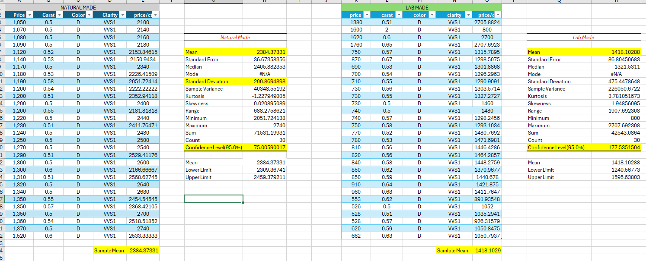

Dashboard:
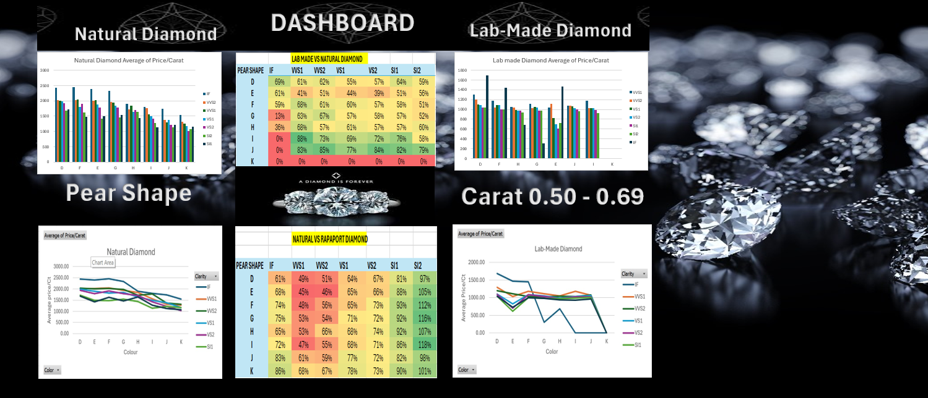

Conclusion:
Our detailed study clearly demonstrates the significant roles that color and clarity play in determining diamond prices. We found that natural diamonds are particularly sensitive to these attributes, more so than lab-made diamonds. This exploration not only deepens our knowledge of how diamonds are valued but also offers practical insights that can be valuable to the industry.

Appendix:
Natural Made Diamond Raw Data
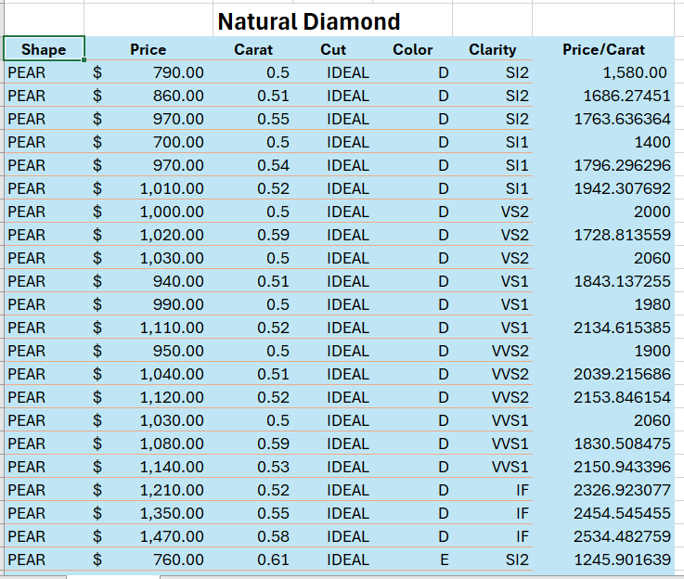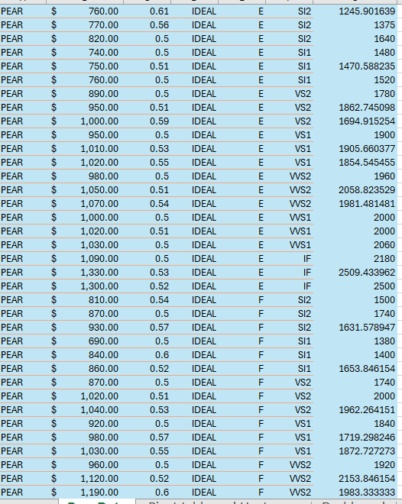

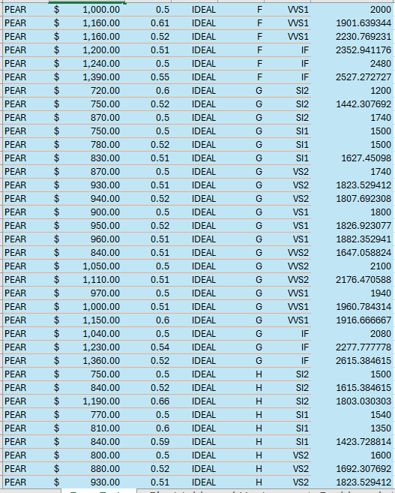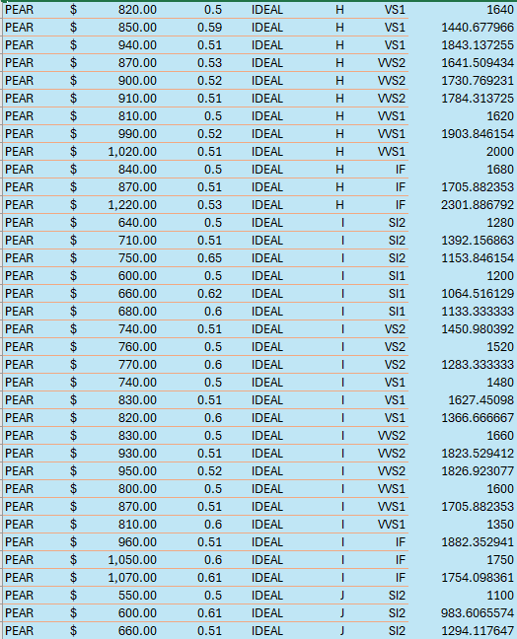
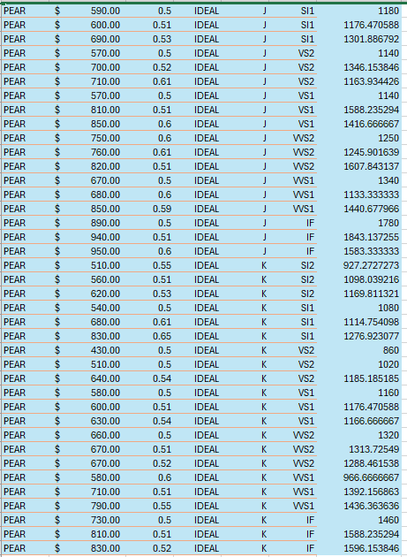
Lab-Made Diamond Raw Data
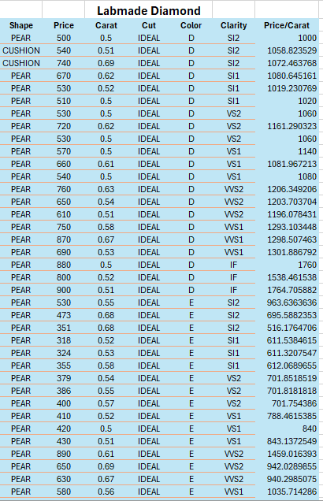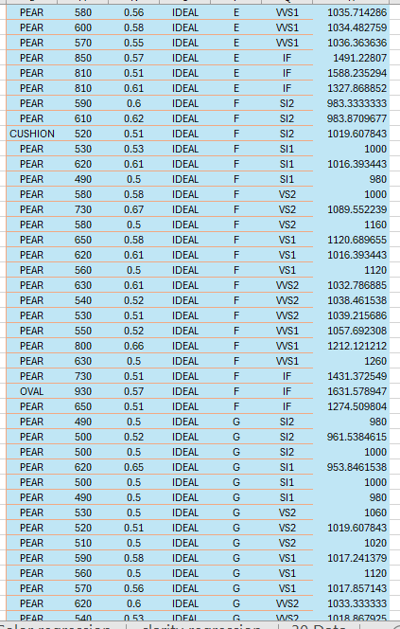
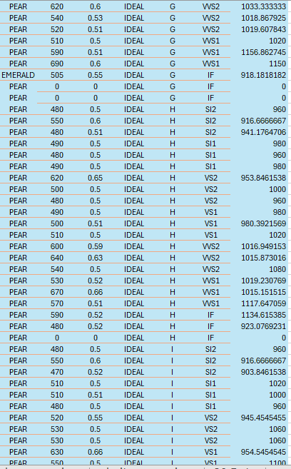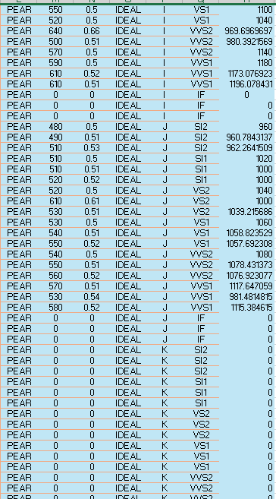

References:
https://www.jamesallen.com/
Brilliant Earth. (n.d.-b). Shop Diamonds: Certified & beyond conflict free - Brilliant Earth. https://www.brilliantearth.com/diamond/
Carat, R. (n.d.). Buy natural diamonds, lab grown diamonds & Engagement rings online. Rare Carat. https://www.rarecarat.com/
Pear Shaped Diamonds. (n.d.). Blue Nile. Retrieved May 1, 2024, from https://www.bluenile.com/diamonds/pear-shaped
With Clarity. (n.d.-a). Natural and lab grown loose diamonds| with clarity. https://www.withclarity.com/pages/diamonds

‌

